Indonesian Foreign Minister Meet Indian Foreign Minister to Discuss Myanmar and G20

Jakarta, 13 July 2023. Indonesian Foreign Minister Retno Marsudi held a bilateral meeting with Indian Foreign Minister Subrahmanyam Jaishankar on the sidelines of the ASEAN Post-Ministerial Conference (PMC) meeting in Jakarta (13/7). Both Foreign Ministers expressed their satisfaction with ongoing bilateral cooperation.

The two Foreign Ministers discussed preparations for the 43rd ASEAN Summit and the G20 Summit, which will be held on 5-7 September 2023 in Indonesia and 9-10 September 2023 in India, respectively. Both agreed to intensify communications so that the two summits run smoothly and lead to beneficial outcomes for the world.

Foreign Minister Retno and Foreign Minister Jaishankar also discussed the issue of Myanmar. India reiterated its support for ASEAN centrality and the 5 Point Consensus.

On 12 July 2023, Foreign Minister Retno met with Foreign Minister Jaishankar and Foreign Minister Penny Wong (Australia) in a Trilateral Meeting format. This was the second meeting, after the first was held in New York City in September 2022.

***

For further information, please contact the following:

Director for Information and Media of the Ministry of Foreign Affairs - Hartyo Harkomoyo (+62811831899)

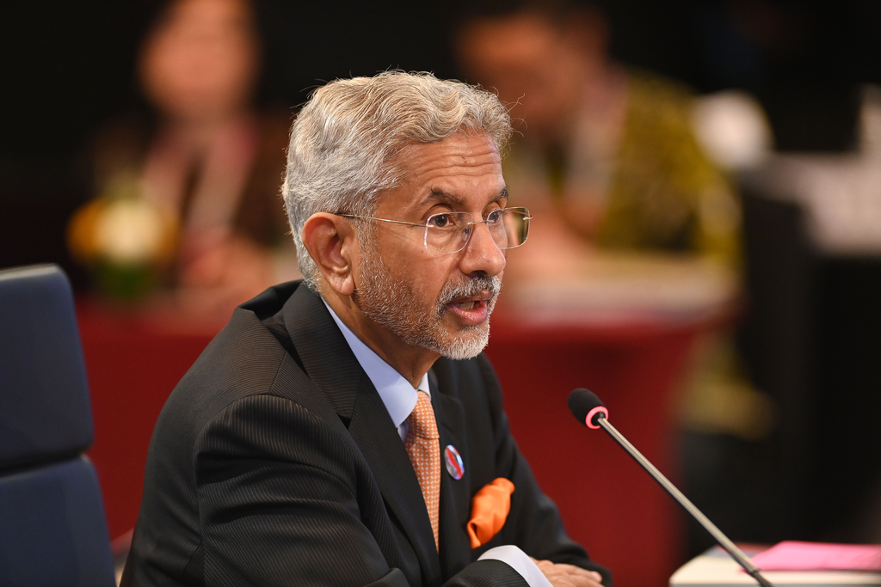

Indonesia-India bilateral meeting with on the sidelines of the ASEAN Post-Ministerial Conference (PMC) meeting in Jakarta (13/7) (Photo: Ministry of Foreign Affairs of Indonesia)

